**MySQL**

**Exercise 2**

1. Select from any table a number and determine whether it is within a given range (for example, between 1 and 10).

Ans:

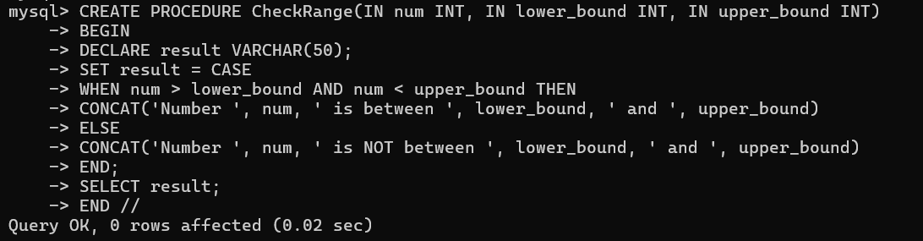

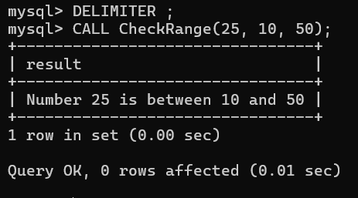

1. Select from any table three positive integers representing the sides of a triangle, and determine whether they form a valid triangle. Hint: In a triangle, the sum of any two sides must always be greater than the third side.

Ans:

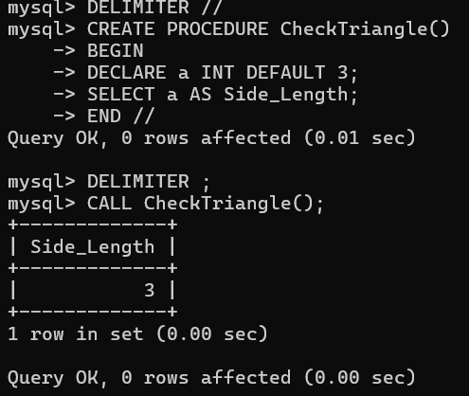

3. Check if a given a year is a leap year. The condition is:- year should be (divisible by 4 and not divisible by 100) or (divisible by 4 and divisible by 400.). The year should be Selected from some table.

Ans:

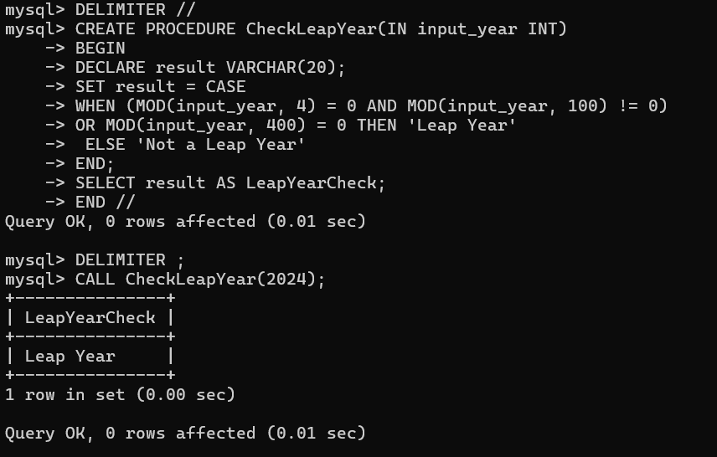

4. Write a program that Selects from any table two character strings. Your program should then determine if one character string exists inside another character string.

Ans:

